**Step 1) Install Java**

Because JMeter is pure Java desktop application, it requires a fully compliant JVM 6 or higher. You can download and install the latest version of Java SE Development Kit. [Download Java Platform (JDK)](http://www.oracle.com/technetwork/java/javase/downloads/index.html)

After installation is finished, you can use the following procedure to check whether Java JDK is installed successfully in your system

* In Window/Linux, go to **Terminal**
* Enter command **java -version**

If the Java runtime environment is installed successfully, you will see the output as the figure below

[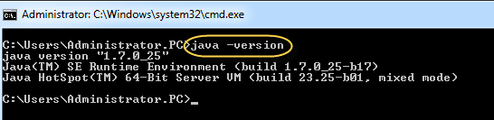](https://www.guru99.com/images/Administrator.png)

If nothing displays, please re-install Java SE runtime environment

### Step 2) Download Jmeter

You can download it [here](https://downloads.apache.org/jmeter/binaries/) – download with name “apache-jmeter-5.3.zip”

### Step 3) Installation

Installation of JMeter is extremely easy and simple. You simply unzip the zip/tar file into the directory where you want JMeter to be installed. There is no tedious installation screen to deal with! Simply unzip and you are done!

Once the unzipping is done installation directory structure should look like as figure below

[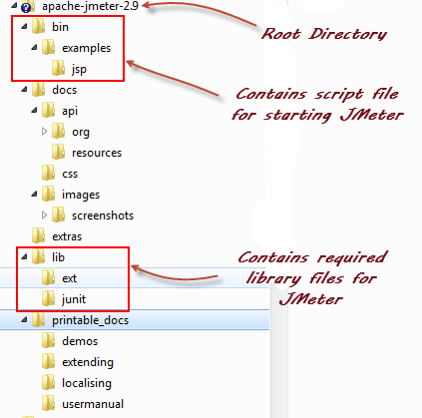](https://www.guru99.com/images/ApacheJmeter2_9.png)

Given below is the description of the JMeter directories and its importance JMeter directory contains many files and directory

* /**bin**: Contains JMeter script file for starting JMeter
* /**docs**: JMeter documentation files
* **/extras**: ant related extra files
* /**lib**/: Contains the required Java library for JMeter
* **/lib/ext**: contains the core jar files for JMeter and the protocols
* **/lib/junit**:[Junit](https://www.guru99.com/junit-tutorial.html)library used for JMeter
* /**printable_docs**:

### Step 4) Launch JMeter

* Just run the file **/bin/ApacheJMeter.jar** to start JMeter in GUI mode as shown below

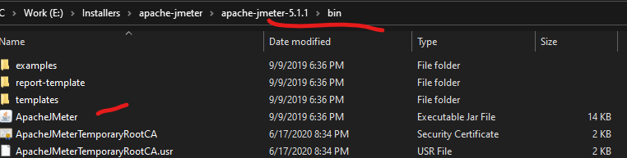

### Step 5) Run JMeter Test

### Two Ways:

### Via GUI

### Start JMeter as per step 4

### Browse File Directory and select .jmx file

### Click on Run button

### Here is the quick video: <https://drive.google.com/file/d/16PwOn83O-aj52S221g34WS54JLeQ_6AN/view?usp=sharing>

### Via Command Line

* + - Go to File Explorer location where .jmx file locater.
    - Open Command Prompt or Powershell
    - Run below command:

jmeter -n -t *filename.*jmx -l *filename*.jtl

* + - After run completed, go to JMeter GUI and view results by loading .jtl file to any Listener i.e. View Results Tree etc.
    - Here is the quick video:

<https://drive.google.com/file/d/1nFzvQb9pYI1qZePy6eHRGiieFF64oBLz/view?usp=sharing>